Class: Final Year (Computer Science and Engineering)
Year: 2024-25 Semester: 1
Course: High Performance Computing Lab

Practical No. 5
Exam Seat No: 22510039

Title of practical: Implementation of OpenMP programs.
Implement following Programs using OpenMP with C:
- Implementation of Matrix-Matrix Multiplication.
- Implementation of Matrix-scalar Multiplication.
- Implementation of Matrix-Vector Multiplication.
- Implementation of Prefix sum.

Problem Statement 1: Implementation of Matrix-Matrix Multiplication
Screenshots:
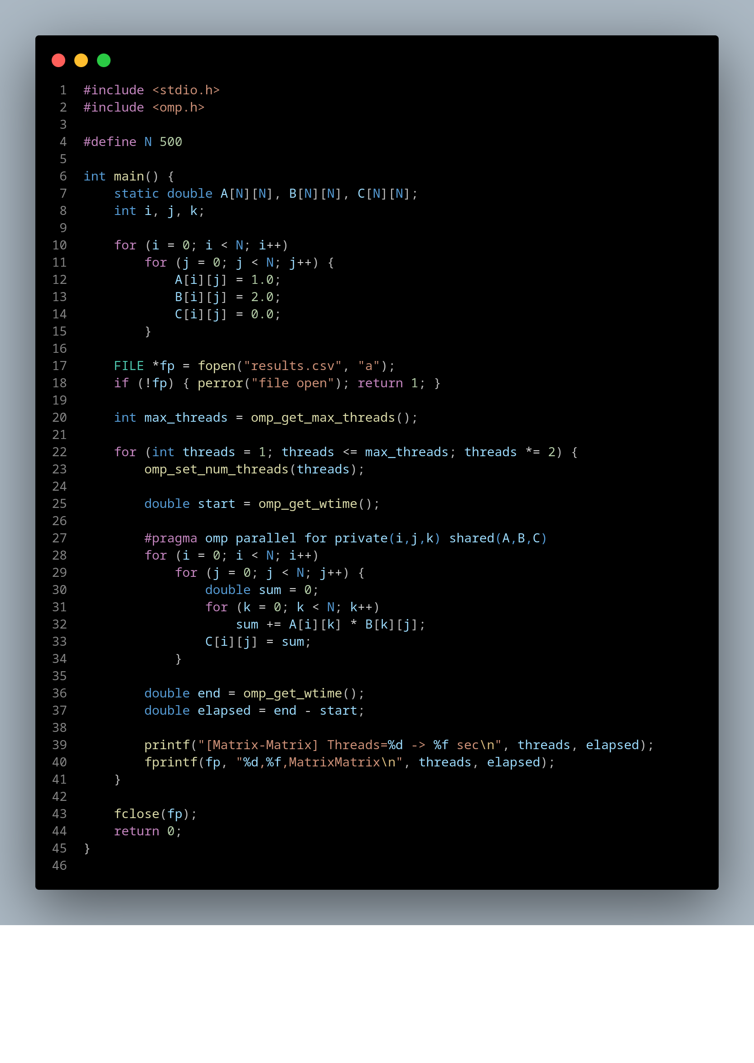
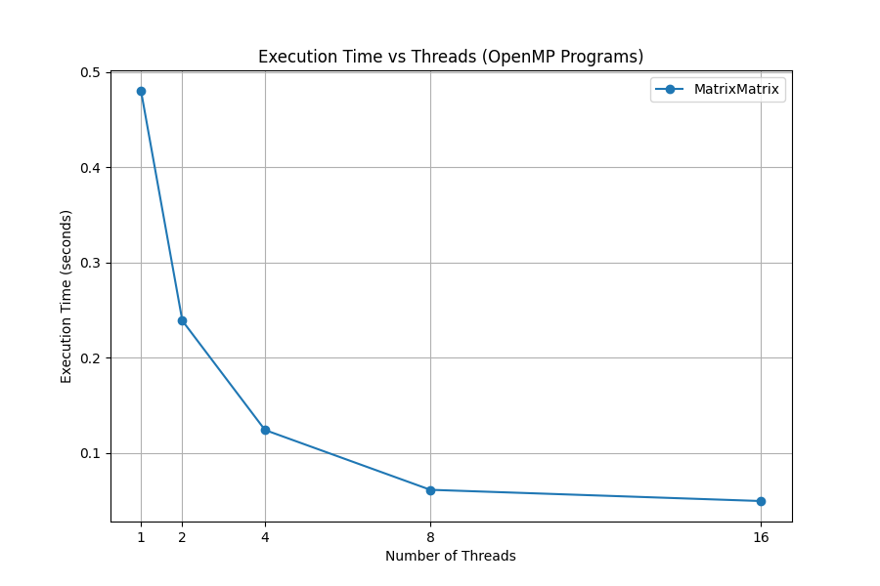
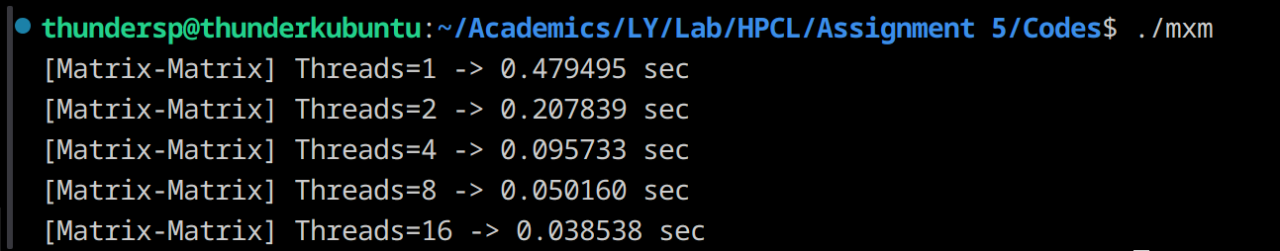
Information:
Computes C = A × B with complexity O(N³).
Very compute-intensive → benefits a lot from parallelization.
Each element C[i][j] is independent → easy to parallelize.

Analysis:
Strong scaling: As threads increase, execution time drops significantly (up to memory bandwidth limit).
Bottleneck: Cache misses. For large N, matrices may not fit in cache, slowing speedup.
Performance expectation: Usually scales well up to ~8–16 threads, then plateaus.

Problem Statement 2: Implementation of Matrix-scalar Multiplication.
Screenshots:
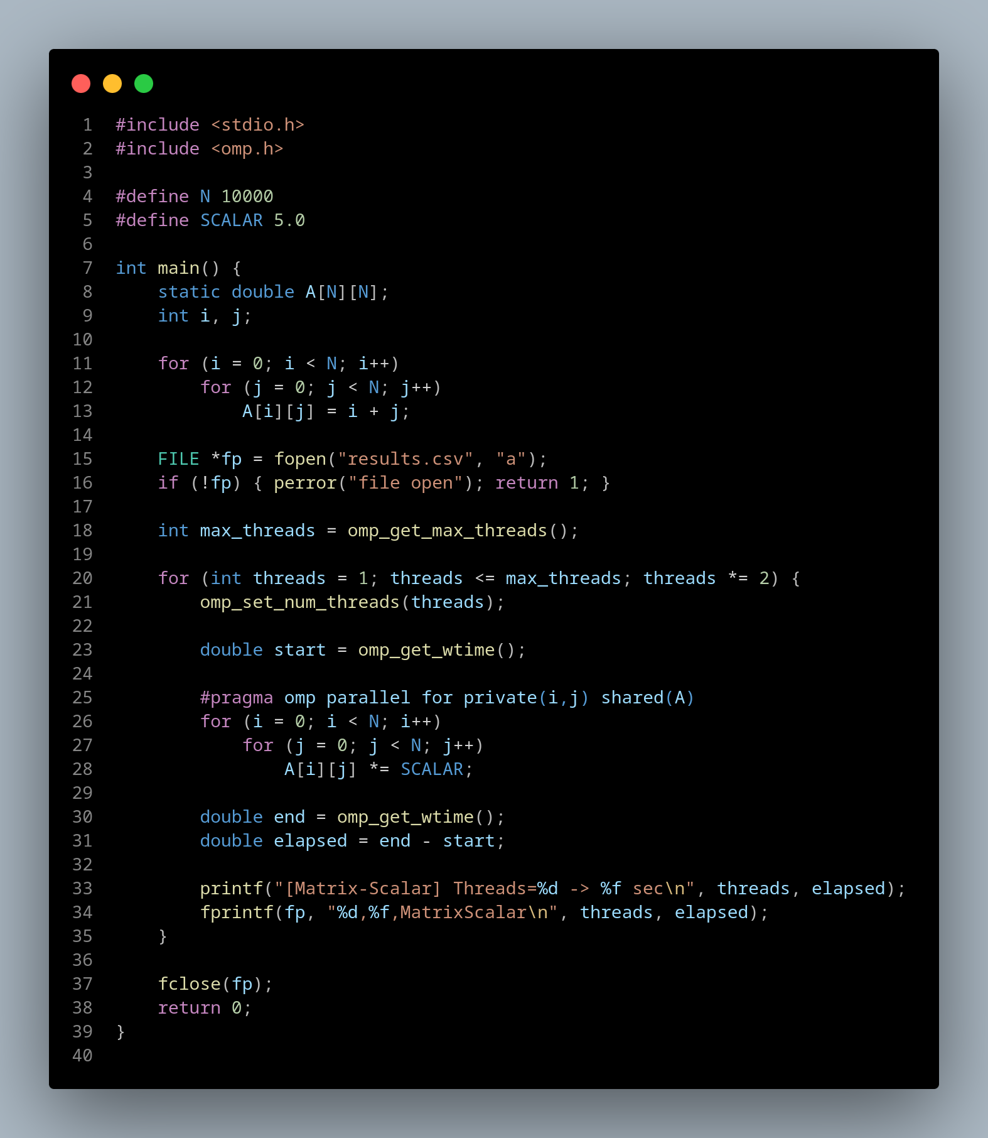
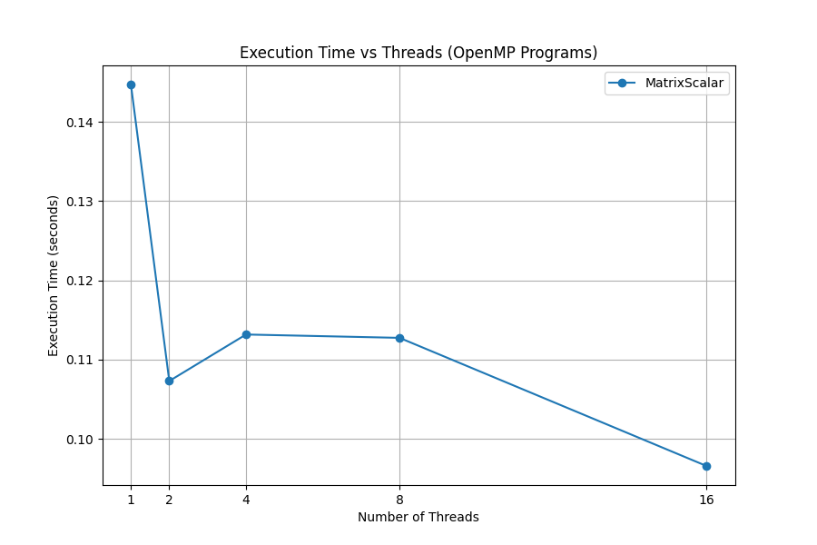
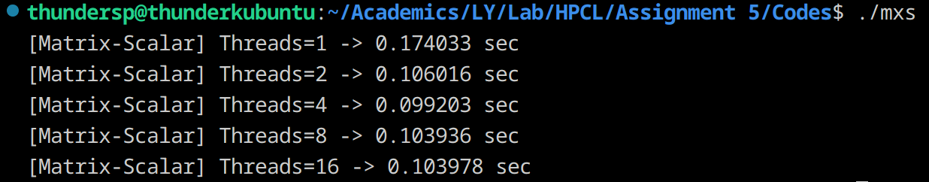
Information:
Simple operation: each element A[i][j] = A[i][j] × scalar.
Complexity O(N²).
Memory-bound, not compute-bound: lots of memory access, very little arithmetic.
Analysis:
- Parallelization overhead may outweigh gains for small matrices.
- Speedup is modest because memory bandwidth is the limiting factor.
- Scaling: Good up to a few cores, then flattens (no more bandwidth).

Problem Statement 3: Implementation of Matrix-Vector Multiplication.
Screenshots:
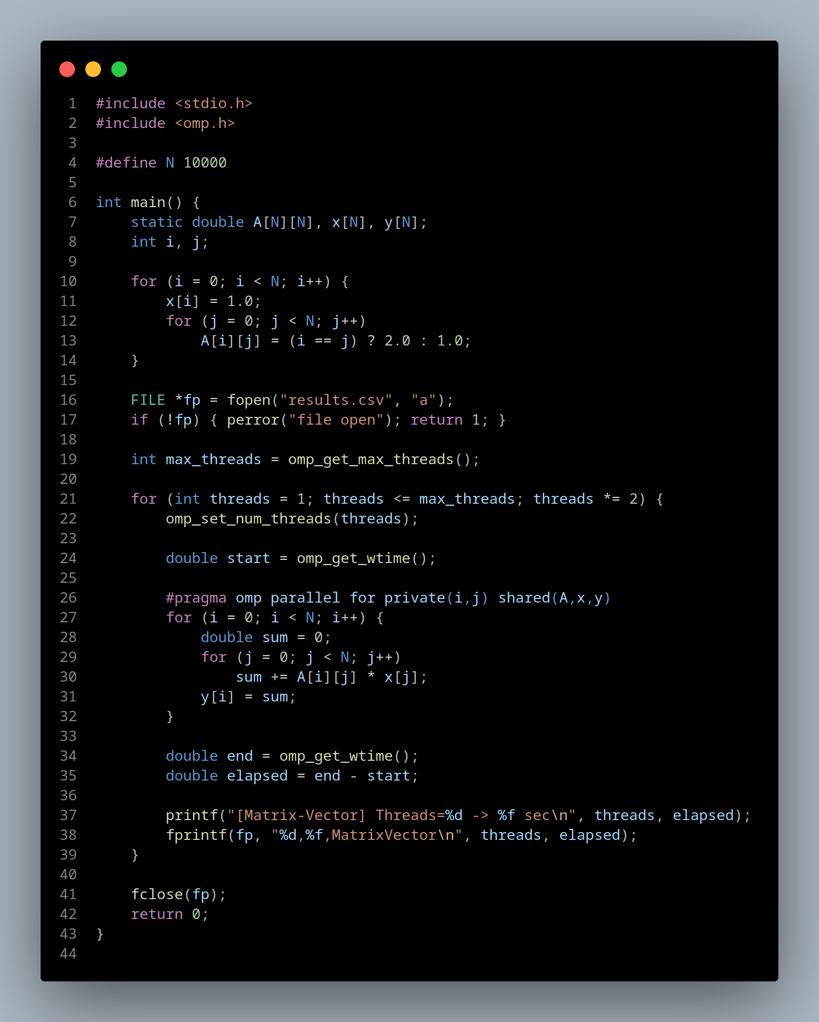
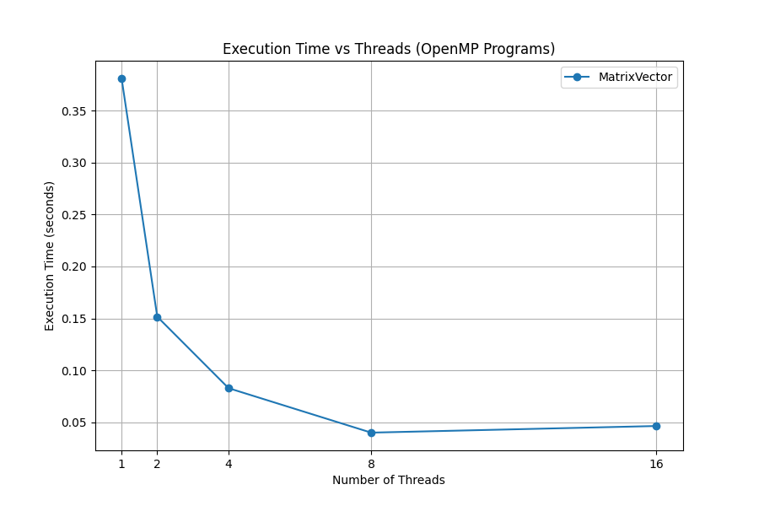
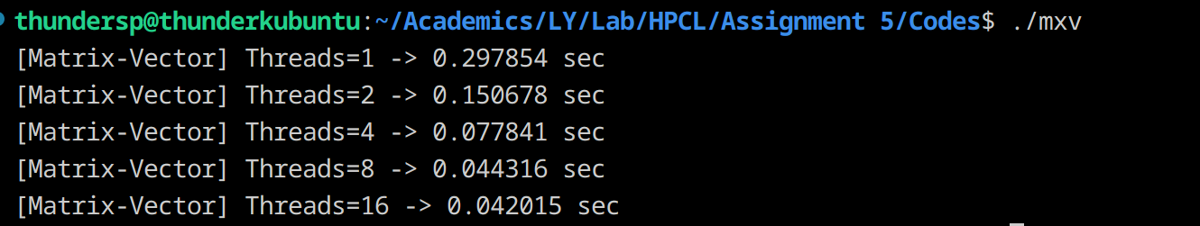
Information:
- Computes y = A × x.
- Complexity O(N²).
- Each output element y[i] is independent → parallelizable.
- Common in linear algebra & ML workloads.
Analysis:
- Faster than matrix–matrix (fewer operations).
- Memory-bound like scalar multiplication.
- Speedup is moderate. Scaling may flatten quickly for large N.
- Often used as a benchmark for memory performance.

Problem Statement 4: Implementation of Prefix sum.
Screenshots:
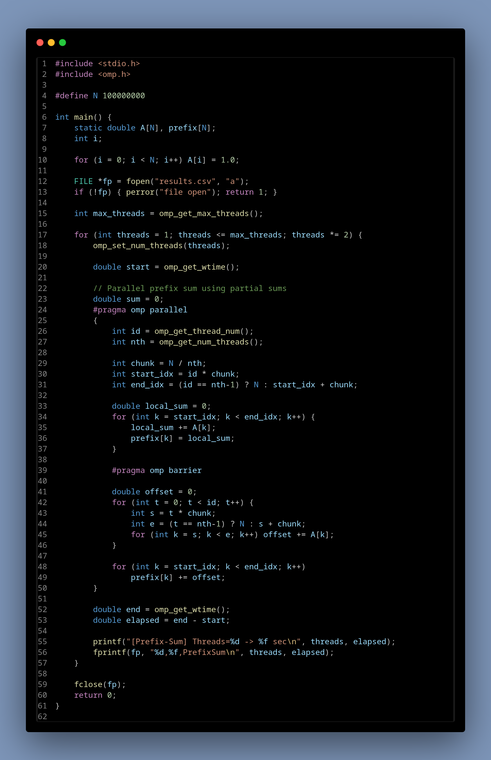
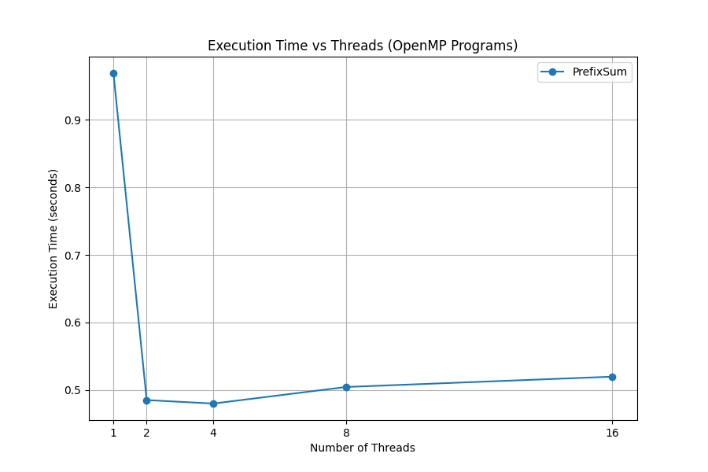
Information:
- Compute prefix: prefix[i] = A[0] + A[1] + ... + A[i].
- Serial complexity: O(N).
- Parallelization is tricky because values depend on earlier ones.
- Uses work-efficient parallel scan algorithms.

Analysis:
- Compute prefix: prefix[i] = A[0] + A[1] + ... + A[i].
- Serial complexity: O(N).
- Parallelization is tricky because values depend on earlier ones.
- Uses work-efficient parallel scan algorithms.

Github Link: https://github.com/thundersp/hpcl

